Mitchell Ramirez
CS-255
11-11-2025
Module 3: Process Modeling
- Interpret the provided data flow diagram. What does it show? What does the current purchase and supply process entail?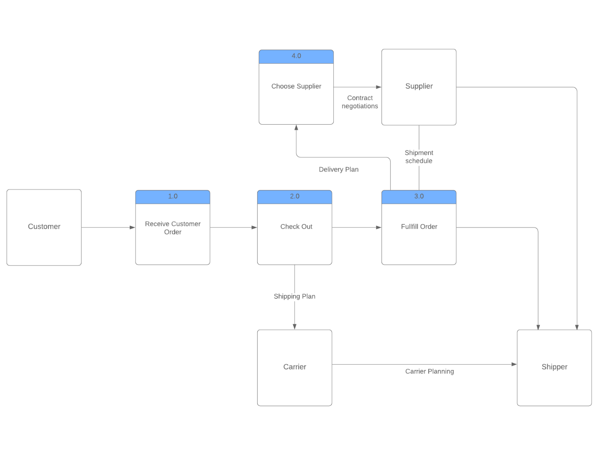
From what I can see from the diagram, it shows me the current purchasing and supply process for Hamp Crafts physical storefront. The purchasing and supply process begins with the customer. When the customer’s order is received by the Receive Customer Order, it then moves to the check out section. The check out process performs two actions or data flows. One is sending the shipping plan to the carrier, which provides the carrier planning to the Shipper. The other data flow is from the Check out process which sends the customer order information to the Fulfill order process. And from there, the delivery plan is then sent to the Choose Supplier process. The process then sends contract negotiations to the Supplier; Fulfill order process and the supplier share shipping schedule with one another. Finally, the fulfill order process and the Supplier send the information and supplies to the supplier
- What are the data sources involved in the current process?
The data sources that are involved with the process are Customer, Supplier, Carrier, and Shipper. These data sources are the four processes sending and receiving information to and from.
- What additional processes are necessary to integrate an online storefront?
The additional processes that are necessary to integrate an online storefront for Hamp Crafts will include an administrative backend, a payment generator, inventory used, and inventory added. The backend process will provide the customer support, update their information, and maintain the website. The payment generator will take payments from the customers, send confirmation of their order, and then send the payment to Hamp Crafts Business Account. The Used Inventory process will update the database on the number of products being sold. The inventory added process updates the inventory database on the number of products added.
- What additional data sources would the system need to access the products and inventory?
An additional source the system would need to include would be the Stock-on-hand and the business account for Hamp Crafts. The stock-on-hand will provide count of the products and the inventory in the inventory database, thus keeping track of everything coming in and out of the company. The business account data source will be where the money from the customer orders will be sent to.
- What additional databases, if any, are needed to support the online storefront?
The additional database needed to support the online storefront is the inventory database. This is where the information on all products and inventory is being held. By having this information stored, it will update Hamp Crafts on what products are being sold and need to be added to the inventory.
- Would you recommend creating a separate new system for the online storefront or incorporating elements of the online storefront into the current process model? Explain your reasoning.
I would recommend incorporating elements of the online storefront into the current model. The reasoning for this is because the elements of the online storefront will fit within the current model, using most of the current processes and data sources. By doing so, this will create a larger system altogether, but I believe it will flow together better and makes more sense in the grand scheme. Because of how it is right now, it causes a lot of overlaps because most of the elements used in each are the same, besides what the new ones are added to. Incorporating the new elements of the online storefront into the current processing model, it will provide a better understanding of how it all works together instead of the individual parts.

